Software Engineering Group Projects
English Tutor
Test Specification

Author: Group 3
Config: SE.QA.06
Date: 25th May 2012
Version: 2.1
Status: Released

Department of Software Engineering College
NorthEastern University
ShenYang
HePing
WenHua Road 14
Copyright © NorthEastern University 2012

CONTENTS

1.Introduction 4
1.1 Purpose of this Document 4
1.2 Scope 4
1.3 Objectives 4
2.Test 4
2.1 Test for login interface 6
2.2 Test for main interface 9
2.3 Test for learning interface 12
2.4 Test for test interface 13
2.5 Test for result interface 14
2.6 Table for test 16
3. REFERENCES 16
4.DOCUMENT CHANGE HISTORY 16

1.Introduction

1.1 Purpose of this Document
This paper is for the “test”, it helps users to test the system.

1.2 Scope
It contains 5 parts, the login interface, the main interface, the test and result interface, the learning interface.
This document is in accordance with the quality standards specified in QA.03 [1] and QA.06 [2].

1.3 Objectives
To find out whether there are any other mistakes in the system.

2.Test
Now we are going to have some tests with our system in order to find out whether there is any mistake with it. Please follow these steps, and we also take some pictures when testing the system.

2.1 Test for login interface
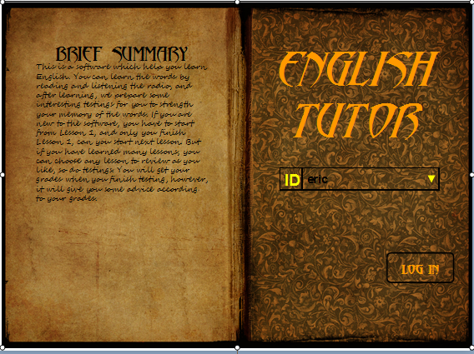
Figure 1: The login interface

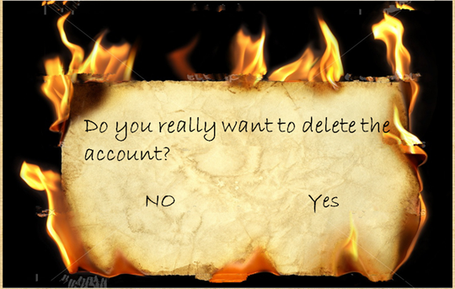
Figure 2: The window to ask for your final decision

Test Ref | Req being tested | Test Content | Input | Output | Pass Criteria
TS1 | FR1 | About creating a new account | Any letters, numbers or Chinese words such as "eric","123","陈俊文", take "eric" as an example | All the character you entered will appear in the blank("eric" appears in the blank), and when you click "Log In", a new account is created | Output is displayed correctly
TS2 | FR1 | About creating a new account | Any notation except letters, numbers and Chinese words such as "#@$"," ", take "#@$" as an example | The new account won't be created, and an error message will turn up. | Output is displayed correctly
TS3 | FR1 | About the existing account | Choose from the record, take "eric" as example which is created in TS1 | When you log in, all your data will be read, and you can continue with the process. | Output is displayed correctly
TS4 | FR1 | About the existing account: Delete the account | Click the "X" following "eric". | A new window appears to ask for your final decision. | Output is displayed correctly
TS5 | FR1 | Final decision of deleting the account. | We assume that you have seen the new window(burning papers). Click "NO" | The burning papers will disappear, and you will return to the "Log in" interface. And the account "eric " still in the record. | Output is displayed correctly
TS6 | FR1 | Final decision of deleting the account. | We assume that you have seen the new window(burning papers). Click "YES". | The new window will disappear, and the "Log-in" interface will appear, however you won't find out "eric" anymore if you don't create it again. | Output is displayed correctly
TS7 | FR2 | New user start with lesson 1 | Create a new account, and log in. For example, input "richard" and log in. | Only lesson 1 in the main interface is available which means its name will be black instead of gray, and gray means unavailable.(You should try to finish lesson 1 in order to prepare for the next test.) | Output is displayed correctly
TS8 | FR3 | Choice for existing user | Choose next lesson not successfully completed. Take "richard" as an example.(we assume that you have finished the task in the last test) | You enter lesson 2's learning interface that you didn't complete last time.(You should learn all the words in this lesson in order to prepare for the next test.) | Output is displayed correctly
TS9 | FR3 | Choice for existing user | Take test for next lesson not successfully completed. Take "richard" as an example.(we assume that you have finished the task in the last test) | You enter the lesson 2's testing interfaces which only have one lesson------lesson 2.(You should finish this test in order to prepare for the next test.) | Output is displayed correctly
TS10 | FR3/FR6 | Choice for existing user | Take test to revise all lessons learned so far, take "richard" as an example.(we assume that you have finished the task in the last test) | You enter the testing interface which include all the lessons you have learned------lesson 1 and lesson 2. | Output is displayed correctly
TS11 | FR3/FR6 | Choice for existing user | Relearn previously done lesson, take "richard" as an example. | You enter the learning interface which includes all the lessons you have learned------lesson 1 and lesson 2. | Output is displayed correctly

2.2 Test for main interface
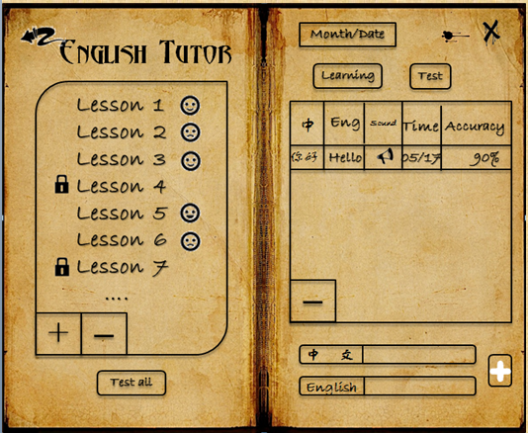
Figure 3: The main interface
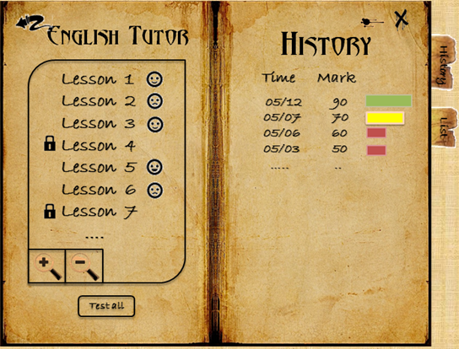
Figure 4: The history interface

Test Ref | Req being tested | Test Content | Input | Output | Pass Criteria
TS12 | FR2 | Check the “return” button. | We assume that you have created the account "richard", and stay in the main interface. Press the “return” button. | Return to the log-in interface. | The Log-in interface is displayed.
TS13 | FR4 | Show the list of lessons. | Take account "richard" as an example. Press the “pull-down menu”  Button. | Show the list of lessons. So far ,you have just finished lesson 1and lesson 2. So only these two lessons are available(lesson's name will appear in black), and the others are unavailable to choose whose lesson name will appear in gray. | The list is displayed successfully
TS14 | FR4 | Show the word of chose lessons. | Click on the chose lesson------lesson 1. | Show the words list which include "Hello  Good morning  Good evening"  and so on. | All words are displayed.
TS15 | FR4 | Check the “pronunciation” button. | Press the “pronunciation” button next to the word "Hello" | The word is pronounced------['heləu ] | The pronunciation is correct.
TS16 | FR4 | Check the “Test” button. | Press the “Test” button. | Cut to the lesson 1's Test interface. | The Test interface is displayed.
TS17 | FR4/FR6 | Check the “Test all” button. | Press the “Test all” button. | Cut to the Test all interface which includes lesson1 and lesson2's words. | The Test all interface is displayed.
TS18 | FR4 | Check the “learning” button. | You should choose lesson 1 first, and press the “learning” button. | Cut to the main “learning” interface for lesson 1. | The main learning interface is displayed.
TS19 | FR4 | Check the "learning" button | If you don't choose any lesson and click the "learning"button | Cut to the main "learning" interface for all lessons you have learned------lesson 1 and lesson 2. | The main learning interface is displayed.
TS20 | FR7 | Check the function of adding lessons. | Input the Chinese and English meanings of a word------"苹果" "apple", then press “add” button. | The word has been added to the new lesson. | The new word displayed in the new lesson.

2.3 Test for learning interface
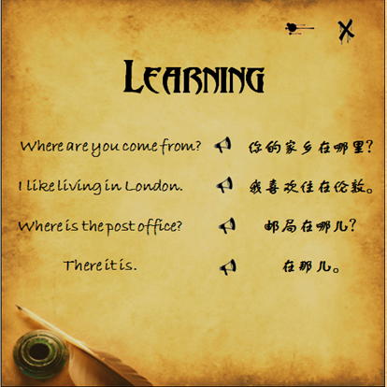
Figure 5 : The learning interface

Test Ref | Req being tested | Test Content | Input | Output | Pass Criteria
TS21 | FR4 | The word is given by the list. | Press the learning in the main interface. | The word in the lesson.  In the list. | The chosen lesson’s words are given by the list.
TS22 | FR4 | Click the Chinese show the English. | Press the Chinese word ”在那里” | The English word ”There it is”. | Show translation.
TS23 | FR4 | The pronunciation button is working | Press the pronunciation button | The voice frequency can be played. | The voice is played and is connected to the right word.
TS24 | FR4 | The shortcut key is working | Press “Esc” in keyboard | Quit the window | Quit the window

2.4 Test for test interface
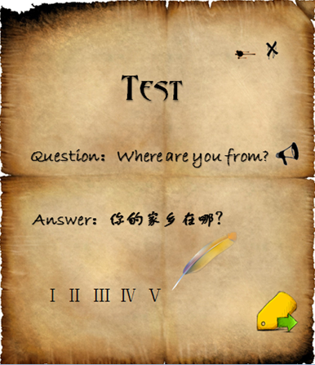
Figure 6: The learning interface

Test Ref | Req being tested | Test Content | Input | Output | Pass Criteria
TS25 | FR5 | The system can give the question randomly. And the next button is working. | Press next button | A new question | Question 1 and question 2 never be the same, and question 1 not always be the same.
TS26 | FR5 | The result window can be shown when the 10 questions is given. | Press the next button when the 10th question is given. | The result window | the next button can work as the finish, when the 10th question is given.
TS27 | FR5 | The system can type in answer correctly. | “Hello” | “Hello” | Custom can type in the input label.
TS28 | FR5 | The sound button is working. | Press the sound button. | The system can give the sound of the question. | Customer can listen the sound of the question.
TS29 | FR5 | The process label can show the process. | Press next button one by one | The pen can write the number of the question. | When the customer skips to next question, the pen can write the number of the question.
TS30 | FR5 | The system can save the answer correctly. | “Hello” | The next question | When the test is finished, it can show all the answers.
TS31 | FR5 | The system can judge whether the answer is right. | “Hello” | √ or × | When the answer is same to the correct answer, it will give√，or it will give ×。
TS32 | FR5 | The shortcut key is working | Press “Esc” in keyboard | Quit the window | Quit the window

2.5 Test for result interface
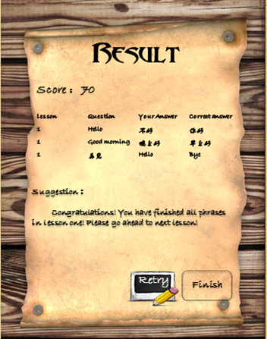
Figure 7: The result interface

Test Ref | Req being tested | Test Content | Input | Output | Pass Criteria
TS33 | FR5 | The system can show the correct score | Press the next button. | The score 8. | Score = the numb of correct answer.
TS34 | FR5 | The table of the test | The button "next" in the test interface(10th question) | The judgments table | Show the ×question in the standard table. And give the correct answer. The question you have correct answer won't appear here.
TS35 | FR5 | The suggestion is working | The score 70 80 90 100. | The suggestion | The suggestion is different with different score
TS36 | FR5 | The retry button is working | Press the retry button | The test window which is just finished. | Show the test window which is just finished.
TS37 | FR5 | The finish button is working. | Press the finish button. | The result window closed return to the main window. | The result window closed return to the main window.
TS38 | FR5 | The shortcut key is working | Press “Esc” in keyboard | Quit the window | Quit the window

2.6 Table for test

Req being tested | Test Ref
FR1 | TS1---TS6
FR2 | TS7,TS12
FR3 | TS8---TS11
FR4 | TS13---TS19,TS21---TS24
FR5 | TS25---TS38
FR6 | TS10,TS11,TS17
FR7 | TS20

3. REFERENCES
[1] QA Document SE.QA.03 - General Documentation Standards.
[2] QA Document SE.QA.05a - Design Specification Standards.

4.DOCUMENT CHANGE HISTORY
Version | Date | Changes | Changed By
1.0 | 2012/5/10 | Document given complete overhaul in Word | Amanda Lucy Richard
2.1 | 2012/5/25 | Follow the standard | Richard Eric

